Research Article
Indonesia's Space Trajectory: Indonesia's Position in the Global Space Business Phase
Shinta Rahma Diana ^{1,}*, Chandra Wijaya ², and Fibria Indriati ³
Received: April 02th, 2025
Revised: April 19th, 2025
Accepted: April 28th, 2025
Published: April 30th, 2025
Curr. Ver.: April 30th, 2025

Copyright: © 2025 by the authors. Submitted for possible open access publication under the terms and conditions of the Creative Commons Attribution (CC BY SA) license (https://creativecommons.org/licenses/by-sa/4.0/)
- Faculty of Administrative Science, University of Indonesia, Indonesia; Research Center for Public Policy, Research Organization for Governance, Economy, Community Welfare, National Research and Innovation Agency; e-mail : shintard3@gmail.com
- Faculty of Administrative Science, University of Indonesia, Indonesia; e-mail : wijayachandra@yahoo.com
- Faculty of Administrative Science, University of Indonesia, Indonesia; e-mail : fibria.indriati@gmail.com
* Corresponding Author: Shinta Rahma Diana shintard3@gmail.com
Abstract: Global space is growing massively, and the current business phase has opened space for non-space actors to play a role. The government-driven space economy is shifting to commercial and new space in the initial phase. This research will examine the trajectory of Space in Indonesia and its position in the global space business phase. The research method uses a qualitative method. The study results show the trajectory of Indonesian Space, from its institutions to policies that support the growth of commercial space and new space phases. The dominance of the Government is still seen in space activities, which are mostly funded by public funds, with products resulting from the mastery of technology not yet entering the operational order. However, economic value can be generated by continuing commercial activities in the commercial space phase, namely the commercial use of space technology with data into value-added information and financial activities from the rental and import of space products by the Private Sector. Indonesia's position in the global space business phase is in the government-driven space economy, which involves several activities from commercial space.
Keywords: Space business; Space economy; Commercial space; New space; Space policy

1. Introduction
The emergence of space institution programs and policies in Indonesia began with the influence of the global (external) environment. As is known, since the 1950s, there has been a "war" of the space program between the US and the Soviets. In this case, war is in the form of competition to carry out Space missions through Space products made and launched, even during that period, on its way to bringing living creatures conducting space exploration.
The first space mission was the launch of the Vanguard satellite, the first satellite launched in 1955 by the United States. Then, 2 (two) years after the Vanguard was launched, the Sputnik Satellite was successfully launched by the Soviets on October 4, 1957, and shortly afterward, with only 1 (one) month later, the Soviets launched Sputnik II on November 3, 1957. This continues where in its development. The Space program also gets attention to be run and developed by other countries, such as India, Japan, China, and others.
The global conditions between the Soviets and the United States in the 1950s provided a deterrent effect that triggered President Sukarno to visit the Soviets to explore cooperation in 1961 and a return visit in 1962. Considering the importance of space, the National Aerospace Aviation Council of the Republic of Indonesia, or LAPAN (Lembaga Penerbangan dan Antariksa Nasional/ National Institute of Aeronautics and Space), was formed through Presidential Decree No. 236 of 1963. Space products were quickly produced, including Gadjah Mada University, successfully launching the Gama 1, 2, 3, and 4 rockets (1963). Not long afterwards, in 1964, Bandung Institute of Technology, PT. Puspa Persada Informatika Dirgantara and the Air Force collaborated to launch the Kartika Rocket. As time passed, various other changes occurred. With various dynamics, Space activities are carried out to produce multiple outputs and outcomes to advance Indonesia's Space program.
Likewise, it relates to global space, which has changed since the space program mission race between the US and the Soviet Union in the 1950s. Space is no longer only related to the military but has entered the civil order and business phase. This era is no longer like when the government or a specific group monopolizes space. Still, it has entered an era that provides opportunities for the Non-Government sector to join and even run businesses in this sector.
A country is competing to advance its space program through the growth of commercialization in the space sector. This is aimed at obtaining economic value that can contribute to their country's economy through their role in the global value chain. Based on this phenomenon, this paper will explore the trajectory of Space in Indonesia to date. By knowing how the Indonesian Space Sector is developing, it will be possible to see the business position of the Indonesian Space Agency in the global business phase. This can make it easier for decision-makers to formulate the right policies or strategies to advance the Space program through the growth of the Space commercial.

2. Literature Review
Global space is experiencing rapid development and entering the commercial and new space phases. Commercial research on Space Expanding, conducted by Davidian [1]; Davidian [2]; Davidian [3]; Peeters [4]; Peeters [5] on the Evolution of Space Economics, Space Commercial or New Space (The development is specific). Its development is described in an open loop diagram by Peeters [5], which consists of the primary loop, namely the government-driven space policy phase, towards the secondary loop in the following phases, namely commercial Space (phase 2) and new Space (phase 3). The fundamental difference lies in the actors who play a role in space activities, where in the initial phase, the government plays a greater role or control over space projects until contracts are made with the Private Aerospace Sectors to carry out development to production from research and development (R&D) results. Meanwhile, in the secondary loop, the actors in this group, namely the Private Sector, are businesspeople who run their businesses using space technology produced by space actors. Thus, the company in this group depends on the processes created in the primary loop (space project), both Space Research and Development (Public Sector) and Development and Production Contracts (Private Aerospace Sector).
The source of funds for running the project in the government-driven space economy is entirely or is financed mainly by the government. The basic project orientation in the primary loop focuses on the Space Project (Space product). Meanwhile, commercial and new space are developing in their current development, where funding is more about private and equity financing, as illustrated in a diagram of the Space business phase by Peeters [5] as follows:
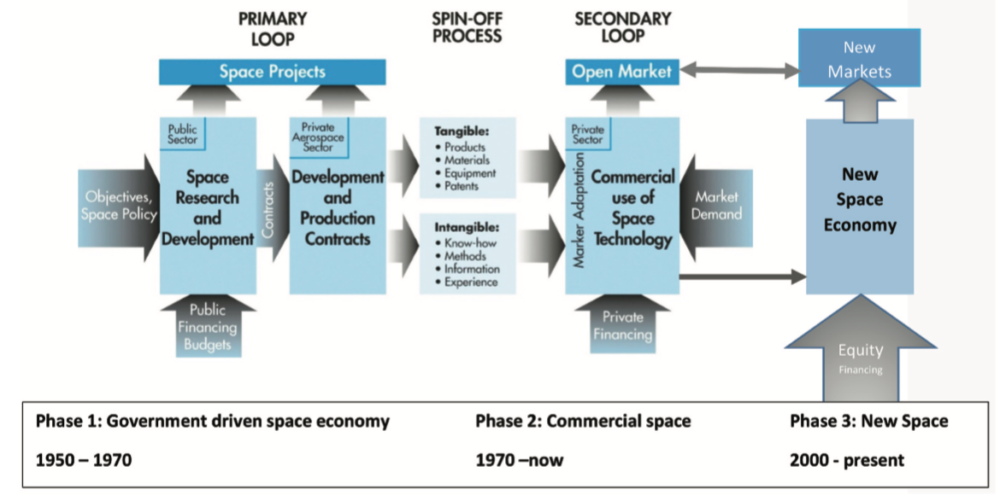
Figure 1. Three phases of the space business.
Source: Peeters [5]
The conditions mentioned above show that the market is more enthusiastic. This can be seen in Figure 1, which shows the existence of open and new markets, which are the expansion of the primary market (markets directly related to the space project). Space projects are in the primary loop, in which activities range from space research and development to creating contracts with private aerospace sectors to carry out development and production from R&D results. The spin-off process will be adapted or further processed to be commercialized through the open market. The open market uses a funding source from private financing.
Furthermore, the company expands its business in new markets by increasing its investments. One is by increasing business capital using equity funding sources or equity financing. This business group is categorized as a new space economy. Global data shows an increase in funding methods using equity financing sources.

3. Research Methods
This paper uses a qualitative technique to accomplish the purpose of this research, which involves descriptive studies. The qualitative method allows the researcher to explore and better understand the complexity of a phenomenon [6]. The qualitative method is a research approach that emphasizes an in-depth understanding of a phenomenon by using non-numerical data collection techniques to build a rich and holistic understanding of the phenomenon being studied. Qualitative data analysis involves identifying the patterns, themes, and meanings behind the collected data [7]. This study uses document analysis to obtain rich and in-depth data.
The research stage in this study begins by writing about the development of Space in Indonesia (its trajectory) using a descriptive method and describing it in a roadmap of institutional development and policies. Furthermore, he wrote about how to commercialize Space in Indonesia. Before answering this, an exploration of the legal basis is first carried out so that the legal force of implementing Space Commercial activities in Indonesia can be known. The next stage is to find out how the position of Indonesian space is in the global space business phase by conducting further mapping using the concept of the space business phase [5].

4. Results and Discussion

4.1. The Trajectory of Indonesian Space
Indonesia's space journey, which began with the influence of the global environment in the 1950s, brought Indonesia to know the world of space. The first President of Indonesia drove the forerunner movement of this sector by exploring cooperation with the Soviet Union in 1961. In January 1962, the Soviets made a return visit to Indonesia. The seriousness of space is evidenced by the establishment of the Astronautical Committee in May 1962 and the National Space Flight Council of the Republic of Indonesia / LAPAN in 1963. In 1993, 30 years after the establishment of LAPAN, a National Aviation and Space Council was formed. The National Aviation and Space Council was formed as a forum for communication between the Government, Industry, and Universities through a consortium. However, in 2014, the National Aviation and Space Council was dissolved (a year after Space Law No. 21 of 2013 was passed) [8]. However, in 1998, the National Aerospace Congress successfully formulated the Conception, Foreign Cooperation Policy, Position of the Republic of Indonesia in Geostationary Orbit, and Identification of Aerospace Development Policy.
The change occurred again in 2021 when all Research and Development Institutions (R&D), namely LIPI (Lembaga Ilmu Pengetahuan Indonesia/ Indonesian Institute of Sciences), LAPAN, BPPT (Badan Pengkajian dan Penerapan Teknologi/ Technology Assessment and Application Agency), BATAN (Badan Tenaga Nuklir Nasional/ National Nuclear Energy Agency), and other Ministries of Institutions that have R&D units were merged into one Agency called BRIN (Badan Riset dan Inovasi Nasional/ National Research and Innovation Agency) through Presidential Regulation No. 78 of 2021 and Presidential Regulation No. 33 of 2021 [9]. Thus, the duties and functions of the Space that LAPAN previously carried out were transferred to BRIN. Figure 2 below is the Institutional Roadmap, including the birth of several Space Policy Products (Institutional roadmap and space policy in Indonesia).
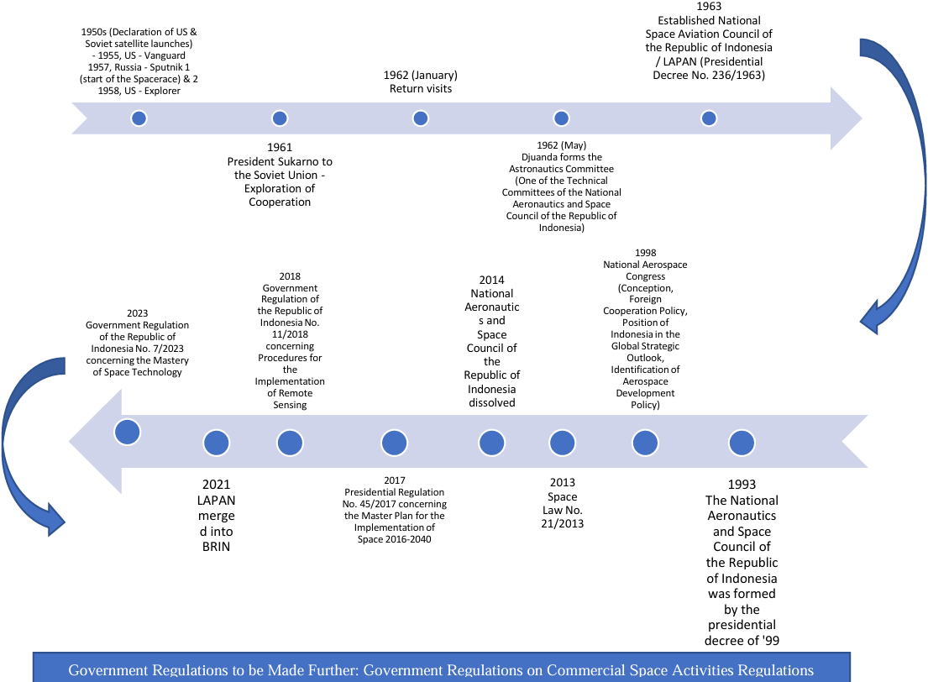
Figure 2. Institutional roadmap and space policy in Indonesia.
As mapped in Figure 2 above, the institutional journey also shows the birth of a policy product in the form of Law of the Republic of Indonesia Number 21 of 2013 concerning Space on August 6, 2013 [8]. This shows that the Indonesian space sector already has a strong legal basis, namely the existence of Law of the Republic of Indonesia Number 21 of 2013 concerning space. Laws and regulations are policies or plans that will be achieved [10]. Thus, the direction in which Indonesia runs in space is directed.
There are also derivative regulations from the Law in the form of a Presidential Regulation (No. 45/2017) on the Master Plan for Space Activities 2016-2040 [11]. A year later 2018, Government Regulation of the Republic of Indonesia No. 11/2018 was issued concerning Procedures for Implementing Remote Sensing [12]. Then, in 2023, Government Regulation of the Republic of Indonesia No. 7/2023 concerning the Mastery of Space Technology will be issued [13]. The mapping of the legal basis of Space in Indonesia based on the hierarchy of laws and regulations in Indonesia is shown in the following Figure 3:
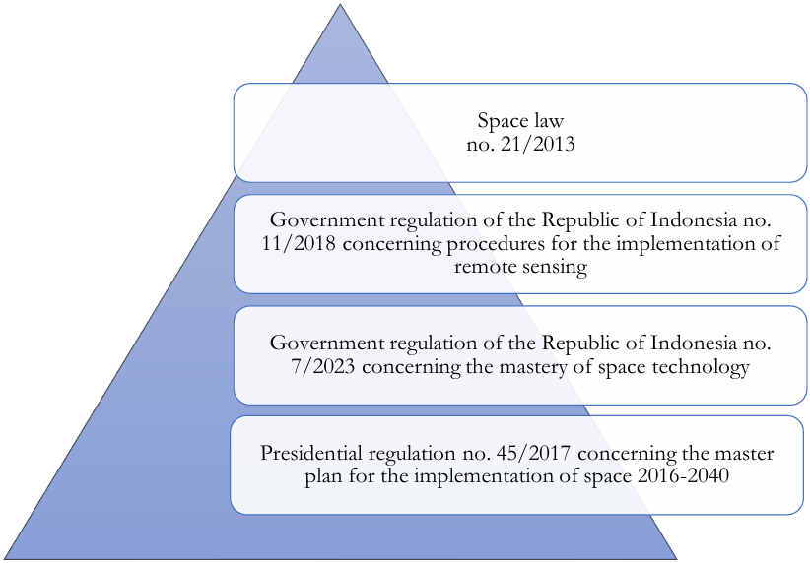
Figure 3. Laws and regulations in Indonesia on space.
The content of Law No. 21/2013 contains articles regarding the commercialization of space. The results of the structural mapping of Law No. 21/2013 show a relatively strong commercialization content in Law No. 21/2013 [8]. This can be seen in Figure 4, where several articles regulate commercial space. The indirect basis for the meaning of commercial importance is contained in one of the objectives of the creation of the Space Law, namely to realize independence and increase the competitiveness of the nation and state in the Implementation of Space (Article 2, paragraph 1) for the productivity of the country (Article 2, paragraph 2). The special mandate regarding the commercialization of space is contained in Chapter II, Article 7, paragraph 1e, which states that Space Commercial is one of the activities of space.
The definition of "commercial activity" is an activity that aims to obtain economic benefits (Explanation of Law No. 21/2013) [8], where this activity can be carried out by a legal entity established under Indonesian and foreign laws (Article 37, paragraph 1). This definition is in line with several commercial definitions of Space and New Space [3], [14-17]. Although there are differences in words or meanings used to describe the commercialization of Space, these differences are agreed to be synonymous [1].
The commercialization content is also strong in Article 37, paragraph 2, which mandates the creation of a Government Regulation that further regulates the requirements and procedures for Space Commercial activities. Based on the description above, the plan aimed at Space in Indonesia related to commercialization is in line with the global trend (Commercial space phase or new space economy). A simpler and clearer picture can be seen in the Structure of the Space Law chart in the following Figure 4:
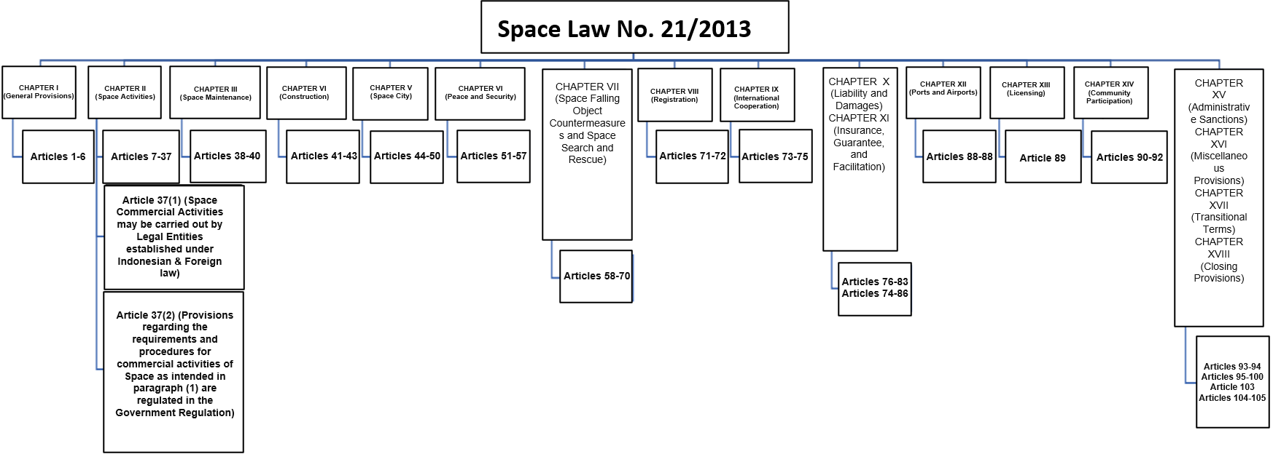
Figure 4. Chart structure of the space law No. 21 of 2013.
The red text in Figure 4 above shows articles on Space Commercial, and the grey box shows articles on the duties and functions of Indonesian Space organizers. In Indonesia, one of the ways commercial activities are carried out can be seen from the implementation of Law No. 21/2013 [8], which has been running for approximately 11 years. Its realization is reflected in the achievements of the Space Master Plan (Line) 2016 - 2040 [11], which is the national guideline for implementing the Space Law.
Based on the results of the evaluation of the Space Shroud for the 2016-2020 period conducted by Pratistha and Triharjanto [18] show that many targets have not been realized, including commercial Space activities and a few programs that have been achieved in Space technology mastery activities. After 2021, a re-evaluation was carried out, which showed that the Space Shroud target for these activities could still not be achieved [19].
The failure to achieve the target of mastering space technology affects the commercial achievements of space. This is because attaining mastery of technology is related to output as the forerunner of the birth of products that can be commercialized. Mastery of technology through activities plays a vital role in growing the commercial Indonesian Space Industry. This is by the concept of how the R&D process is carried out until the benefits of technology are obtained. Thus, mastery of technology can be the forerunner of commercialization growth. This can be seen in the innovation process, which shows the cycle shown in Figure 5 (R&D to Commercialization Process) [20].
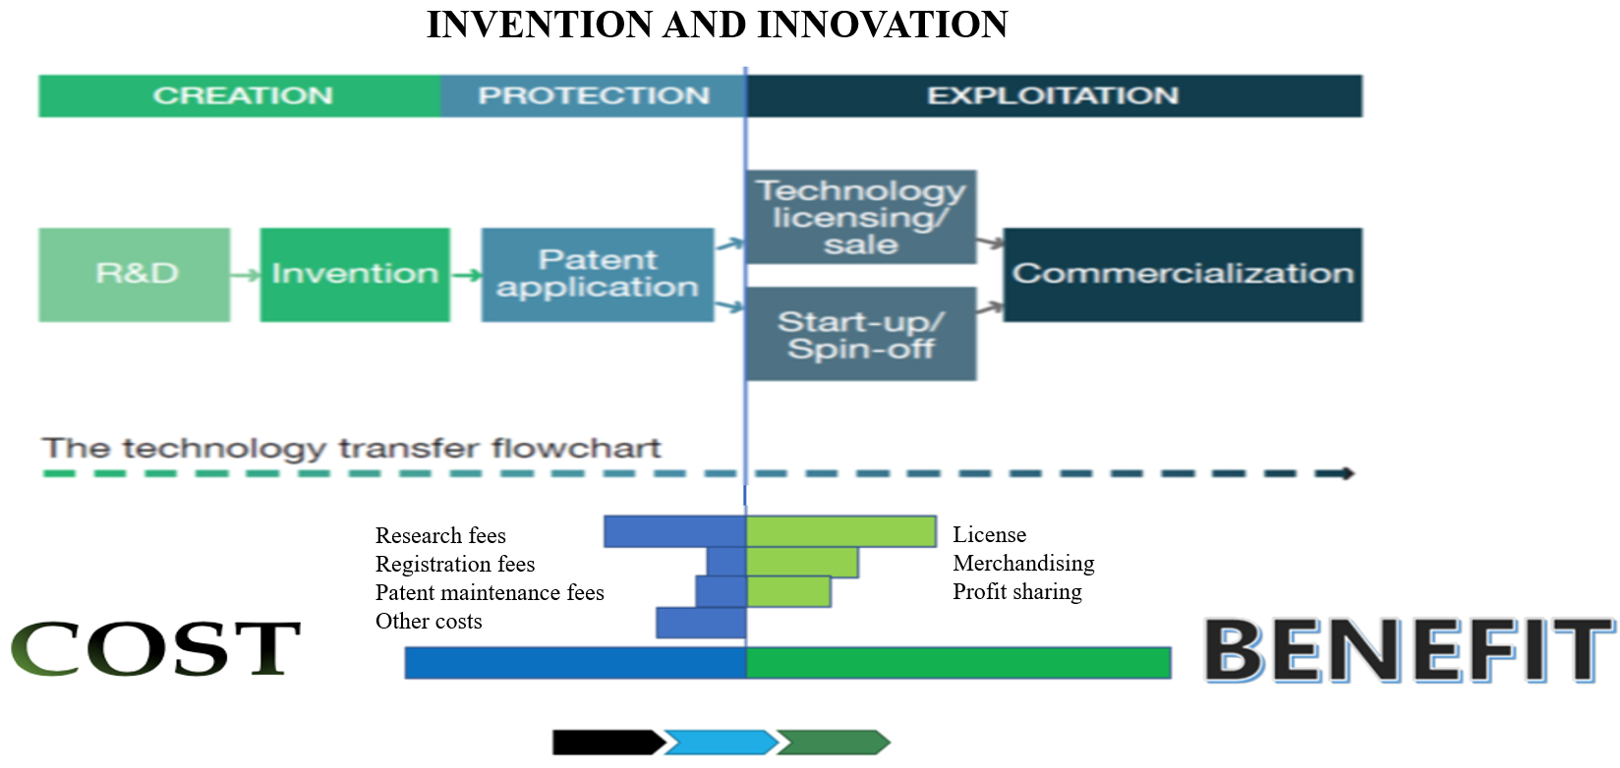
Figure 5. R&D to commercialization process.
Source: Meutia [20]
Figure 5 shows the innovation process, which starts with creation, protection, and exploitation. Creation consists of a series of activities that require economic sacrifices, including expenses for research costs, registration fees, patent maintenance costs, and other costs. Thus, activities in this group are categorized as costs. Activities in this group range from R&D activities to the acquisition of patents. Mastery of technology begins with the R&D process, which results in inventions.
Furthermore, protection is carried out by protecting patents for the novelty of technology that has been successfully created. Benefits are then obtained through the process of technology adoption. In the exploitation group, economic benefits or advantages are obtained from the previous stage of the process (creation and protection). Commercialization is obtained through economic activities (technology licensing/sale or start-up/spin-off).
The above theory is also strengthened by another theory that discusses innovation: the Funnel model theory [21]. The Funnel Models innovation process consists of 9 (nine) elements or stages, which are grouped into three parts, namely inputs (Strategic Thinking and Portfolio Management and Metrics), processes (Research Ideation, Insight Targeting Innovation Development and Market Development), and output (Sales). The process then rotates back into the input process, and so on.
Thus, as written above, related to the unattainability of space commercial activities is due to the lack of mastery of key technologies, a fundamental aspect of commercial growth. As an illustration, here is a map illustrating how far space technology has been developed in Indonesia. The following is a mapping of Indonesian Space products in the form of products made from the R&D of Indonesian Space Technology Mastery (outside the dotted line) or those derived from purchases contained in Figure 6:
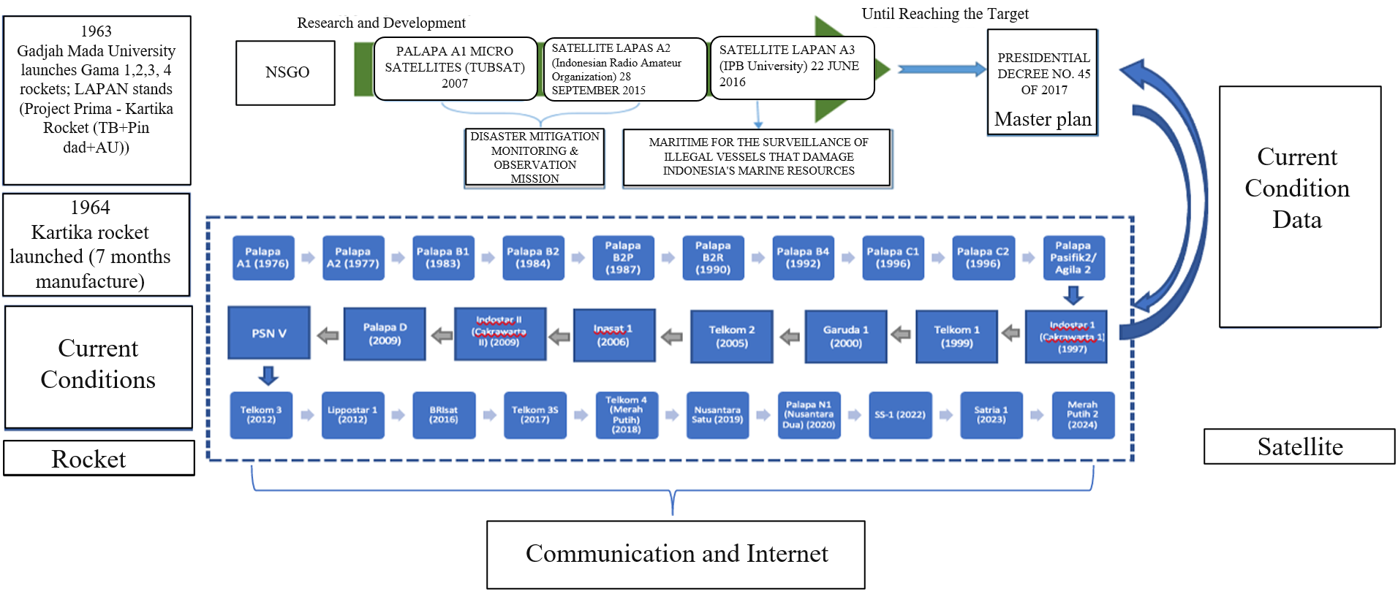
Figure 6. Space products.
Figure 6 (space products) provides an overview of Indonesian Space Products which are upstream products in the form of satellites and rockets. Overall, it shows the significant role of the Government in space activities, where Indonesia has launched rockets since 1963 as well as satellites in 1976. In its development, various types of rockets have been successfully developed, including Experimental Rocket-100, Experimental Rocket-120, Experimental Rocket-360, Experimental Rocket-450 (mission as a low-orbit launch rocket), and Experimental Rocket-550 [22]. However, this rocket has not yet reached orbit, it is still an experimental rocket.
Regarding developments in satellite products, since Indonesia first launched the Palapa satellite on July 9, 1976, the number of Indonesian satellites has been minimal, and it can even be said that Indonesia is significantly lagging behind countries in the Asia Pacific and even in ASEAN countries [23]. The new homemade satellite was launched in 2007, namely the LAPAN-A1 Microsatellite. Following 9 years later, the LAPAN-A2 Satellite (Indonesian Radio Amateur Organization) was launched in 2015, and the last to be launched was the LAPAN-A3 Satellite (IPB University), which was launched in 2016, a year after the Indonesian Radio Amateur Organization Satellite was launched. The mission of the three satellites is for research purposes, and they were launched in a Non-Geostationary Satellite Orbit. The current development in the national target in space exploration should have entered the stage of launching the LAPAN-A4 and LAPAN-A5 satellites, which has been 10 years since the launch of the LAPAN-A3 satellite.
Surya University launched the last Indonesian research satellite, the Surya Satellite-1 (a nano satellite). Surya Satellite-1 was launched via the SpaceXCRS launch vehicle on November 27, 2022. This satellite's function includes sending SMS anywhere, such as an earthquake sensor or tsunami, to commercial needs such as asset tracking. All of the satellites launched, ranging from the LAPAN-A1, LAPAN-A2 (in collaboration with the Indonesian Radio Amateur Organization), LAPAN-A3 (with IPB University), and Surya Satellite-1 (a nano satellite), are Indonesian-made satellites that have gone through the Research and Development (R&D) process.
In addition to the research satellites mentioned above, some satellites are launched in Geostationary Orbit for commercial activities (operational satellites) purchased from foreigners (not homemade). Currently, there are no homemade Indonesian operational satellites. Some of the latest operational satellites launched include Telkom, which launched several satellites, including Telkom 4 (Merah Putih/ Red and White) on August 7, 2018. Satelit Nusantara 1 was launched on February 21, 2019, by PT. Pasifik Satelit Nusantara. PT. Pasifik Satelit Nusantara launched the SATRIA A-1 Satellite on June 19, 2023, and Telkomsat's Red and White Satellite 2 was launched on February 21, 2024. Not all companies have successfully launched their satellites; for example, Palapa N1 (Nusantara Dua/ Nusantara Two), which was launched on April 9, 2020, by Xichang Satellite Launch Center (XLSC), failed to launch on the Long March-3B launch vehicle (Chang Zheng-3B).

4.2. Indonesia's Space Trajectory in the Global Space Business Phase
After learning about the trajectory of Indonesian space and its level of achievement, it is necessary to carry out further mapping to find out how it stands in the global space business phase. The mapping was carried out using the space business phase concept to determine the extent to which Indonesia's commercial activities are growing. Products produced in the Space sector that are included in the commercial category are in order of entry into the market. This is due to the concept of the definition of commercial, as discussed earlier, that what is said to be commercial is an activity that brings profit or that can be monetized. In each space business phase, a market is a supply to meet the demand of a need.
The first part is phase 1, where the group in this phase is a group of space actors. Although it has entered the manufacturing process stage of the R&D, the development and production contracts process has not been carried out with the private aerospace sector. The development process carried out to create space products that reach orbit is carried out by the government, where the nature of the product is a public good. The majority of its usefulness is for research purposes. The value economy generated from phase 1 has not yet reached sales from the results of self-production (Aerospace manufacturing products). This is because the technology produced from the results of R&D has not been categorized as an Operational Space product.
However, in phase 1 of the space business, some benefits can be monetized, which will enter the following process: in phase 2. This economic value comes from the space sector in remote sensing from the LAPAN-A1, LAPAN-A2 (in collaboration with the Indonesian Radio Amateur Organization), and LAPAN-A3 (with IPB University) microsatellite products, whose satellite data is processed into economic value information. In addition to the financial value obtained from technology mastery activities, as mentioned above, other commercial activities come from the activities of using space technology that grows from phase 2 of the Space business, which is in the form of business processes from the rental system and the import of upstream products from foreign parties. Upstream product rentals include medium, high, and very high-resolution sensing satellites, while the import of space products or the purchase of satellite products is intended for communication missions that include internet, navigation, and broadcasting. Regarding phase 3 of the space business, which is a new market where the funding uses private financing and equity financing, the private sector in Indonesia has not used this business method in developing its business.
The legal basis that accommodates the commercialization of Space in Indonesia is quite strong, namely with Space Law No. 21 of 2013 concerning Space [8], which contains articles that regulate commercial space, which is a form of support for the growth of commercial space in Indonesia. This can be a strong forum to encourage space activities to develop rapidly. The opening of the market and business expansion through equity financing can open up space for the government and the private sector to collaborate in strengthening the mastery of space technology (rockets and satellites) that can be commercialized.

5. Conclusions
The government still dominates the development of Indonesian space. This can be seen from the projects produced using public or government funds. Products created from the mastery of technology have not entered the operational order. However, there are commercial activities from the business process in commercial space, namely from the use of space technology derived from the rental and import of space products by the private sector. These activities use private financing but have not yet reached the stage of funding through equity financing sources. Thus, Indonesia's position in the space business phase remains in a government-driven space economy, with several commercial space activities originating from leases and imports.
Efforts are needed to encourage commercial space, especially the new space economy, to grow in Indonesia by stimulating new markets so that Indonesia can also become a business player in global space. A space program that can encourage the participation of business people, both Space and non-space actors, is needed. It is recommended that the creation of a government project in collaboration with the private sector, using the expansion of funding sources that open up more expansive collaboration space through the equity financing method, be done. This method can allow movement in all space business actors to open up opportunities for the movement of loops in the space business phase from the primary loop to the secondary loop, and the process runs again to the primary loop.

Author Contributions: Conceptualization: S.R.D. and C.W.; Methodology: F.I.; Software: S.R.D.; Validation: C.W. and F.I.; Formal analysis: S.R.D.; Investigation: S.R.D.; Resources: S.R.D.; Data curation: S.R.D.; Writing—original draft preparation: S.R.D.; Writing—review and editing: S.R.D.; Visualization: S.R.D.; Supervision: C.W. and F.I.; Project administration: S.R.D.; Funding acquisition: S.R.D.”
Funding: This research received no external funding.
Data Availability Statement: No new data were created or analyzed in this study.
Conflicts of Interest: The author declares no conflict of interest.

References
[1] K. Davidian, "Operationalizing the definition of “commercial space”", Acta Astronautica, Vol. 198, 2022, p. 541–549. doi: 10.1016/j.actaastro.2022.06.040.
[2] K. Davidian, "What makes space activities commercial?" Acta Astronautica, Vol. 182, p. 547–558, 2021, doi: 10.1016/j.actaastro.2021.02.031.
[3] K. Davidian, "Do ‘commercial’ space companies exist?", New Sp, Vol. 4 (4), p. 269–285, 2016, doi: 10.1089/space.2016.0003.
[4] W. Peeters, "Toward a definition of new space? The entrepreneurial perspective", New Space, Vol. 6 (3), p. 187–190, 2018.
[5] W. Peeters, "Evolution of the space economy: Government space to commercial space and new space", Astropolitics, Vol. 19(3), p. 206–222, 2021.
[6] H. Mohajan, "Qualitative research methodology in social sciences and related subjects". Journal of Economic Development, Environment and People, Vol. 7 (1), p. 23–48, 2018.
[7] J. W. Creswell, & J. D. Creswell, "Research design: Qualitative, quantitative, and mixed methods approaches," California: SAGE publications, 2023.
[8] Republic of Indonesia, "Undang undang nomor 21 tahun 2013 tentang keantariksaan. (Law number 21 of 2013 concerning outer space", Jakarta: Kementerian Sekretariat Negara, 2013.
[9] Republic of Indonesia, "Peraturan presiden nomor 78 tahun 2021 tentang badan riset dan inovasi nasional (Presidential Regulation number 78 of 2021 concerning the National Research and Innovation Agency)", Jakarta: Kementerian Sekretariat Negara, 2021.
[10] N. T. Hastuti, "Mengukur derajat jenis dan fungsi dalam hierarki peraturan perundang-undangan pasal 7 (4) undang-undang no. 10 tahun 2004 tentang pembentukan peraturan perundang-undangan (Measuring the degree of type and function in the hierarchy of legislation article 7 (4) of law no. 10 of 2004 concerning the formation of legislation)", Perspektif, Vol. 12 (3), p. 196–206, 2007.
[11] Republic of Indonesia, "Peraturan presiden nomor 45 tahun 2017 tentang rencana induk penyelenggaraan keantariksaan 2016-2040 (Presidential regulation number 45 of 2017 concerning the master plan for the implementation of space affairs 2016-2040)", Jakarta: Kementerian Sekretariat Negara, 2017.
[12] Republic of Indonesia, "Peraturan pemerintah nomor 11 tahun 2018 tentang tata cara penyelenggaraan kegiatan penginderaan jauh (Government regulation number 11 of 2018 concerning procedures for organizing remote sensing activities)". Jakarta: Kementerian Sekretariat Negara, 2018.
[13] Republic of Indonesia, "Peraturan pemerintah republik indonesia no. 7/2023 tentang penguasaan teknologi keantariksaan (Government regulation of the republic of indonesia no. 7/2023 concerning mastery of space technology)", Jakarta: Kementerian Sekretariat Negara, 2023.
[14] G. Autry, "Exploring new space: Governmental roles in the emergence of new communities of high-technology organizations," 2013, Irvine: University of California.
[15] L. Culver, L. Escudero, A. Grindle, M. Hamilton, & J. Sowell. "Policies, incentives, and growth in the newspace industry," Commercial Space Working Paper, vol. 1, P. 1–94, 2017.
[16] S. D. Ciaccio, A. Cramarossa, & M. Fatica, "New space: a glance at Italy," New Sp. Vol. 6 (4), p. 254–261, 2018, doi: 10.1089/space.2018.0021.
[17] B. Lal, & R. Wei, "What is commercial space? and why does it matter?", In Proceedings of the 2019 IAF International Astronautical Congress, October, 21–25, Washington, DC, 2019.
[18] B. Pratistha, & R. H. Triharjanto, "Evaluasi on going rencana induk penyelenggaraan keantariksaan tahun 2016-2040 (On Going Evaluation of the Master Plan for Space Management 2016-2040)", Jurnal Kajian Kebijakan Penerbangan dan Antariksa, Vol. 1, p. 36–49, 2020.
[19] Intellectual Property Directory. "Kajian Kedeputian Kebijakan Riset dan inovasi (Research and Innovation Policy Deputy Study)", Jakarta: BRIN, 2023.
[20] D. Meutia, "Komersialisasi Paten dan Royalti bagi Peneliti (Patent Commercialization and Royalties for Researchers)", Jakarta: Direktorat Jenderal Kekayaan Intelektual Kementerian Hukum dan Hak Asasi Manusia, 2022.
[21] D. Gamal, E. T, Salah, & E. N. Elrayyes, "How to measure organization innovativeness", Giza: Technology innovation and entrepreneurship center, 2011.
[22] F. Nua, "Ternyata, Indonesia negara kedua di asia yang luncurkan roket (Apparently, Indonesia is the second country in Asia to launch a rocket)", Media Indonesia, 2020. [Online]. Available: https://mediaindonesia.com/humaniora/365798/ternyata-indonesia-negara-kedua-di-asia-yang-luncurkan-roket.
[23] G. Damanik, "Membangun toll angkasa melalui two layer function model untuk memenuhi kebutuhan kapasitas satelit di Indonesia (Building a space toll road through a two-layer function model to meet satellite capacity needs in Indonesia)', Disertasi, Satya Wacana University Press, 2017.

